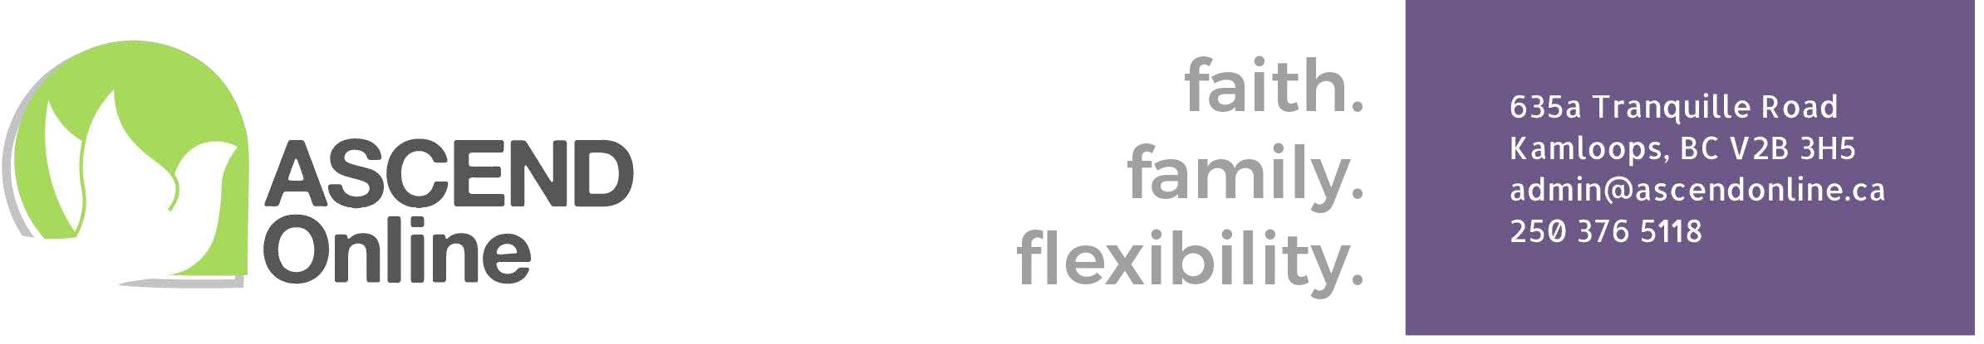

Parent Agreement
ASCEND Online is a Catholic School under the Diocese of Kamloops. As such, ASCEND affirms parents as the primary educators of their children and promotes the parent-child relationship in the learning process. When enrolling with ASCEND, a parent accepts that ASCEND will receive provincial government funding to support their child’s educational program. With this funding comes certain privileges and responsibilities for the Ministry of Education, the school and the parents.

As a parent of a student enrolled in K – 12 with ASCEND Online, it is required that you agree to the following:
- I will facilitate weekly contact between my child and my child’s contact teacher. This can be done in a variety of ways: through FreshGrade, learning samples, Zoom meetings, phone calls, in-person meetings, webinars, emails, co-op, workshops, etc.
- I will need internet access for various purposes (to view ASCEND’s online SLPs, report cards, communication, Canvas access, etc.).
- Texts, non-consumable curriculum, or equipment purchased are school property. All items will be returned to ASCEND Online when no longer needed or if my child is no longer enrolled with ASCEND. If I wish to keep the materials or equipment, I will reimburse ASCEND Online $25 per child, up to a maximum of $100 per family. Lost, stolen, or damaged items are the responsibility of the family.
- Any computer, tablet or equipment purchased with funding remains school property according to the signed Computer/Equipment Lease Agreement.

In addition, parents of students in K-9 agree to:

- communicate with my child’s contact teacher to establish a Student Learning Plan (SLP) and be available for regular communication throughout the year.
- Ensure all purchases are approved by my child’s contact teacher and are in alignment with the SLP before using our Purchase Order Number (PO#).
- I will not exceed $600 per student when purchasing consumables (workbooks, etc.) and 3rd party services (such as music lessons, art classes, sports activities, etc.).
- submit three learning samples in October and continue to share evidence of student learning with the contact teacher throughout the school year.
- provide every opportunity possible to have students complete the Foundation Skills Assessments. ASCEND Online respects the Ministry of Education’s annual province-wide assessment of BC students in Grades 4 and 7 and appreciates parents’ support in the administration of these assessments.
- meet with the Grad Transitions counsellor in May of Grade 9 to plan for high school, graduation, and post-secondary options.

And parents of students in 10 – 12 agree to:

- encourage/facilitate my child’s participation in weekly communications with their teacher(s).
- check in with my child periodically to ensure appropriate pacing of coursework within each of their courses.
- meet with the Grad Transitions counsellor once per year (usually May) to discuss course enrolments, course registration, coursework schedules, etc.
- attend Parent-Teacher interviews, as scheduled, twice throughout the school year.

My signature below indicates that I have read, understand and agree to the ASCEND parent responsibilities.

Parent/Guardian Signature: _________________________________________

Name of child(ren): ____________________________________________________

Date: _______________________________

